Part 1 :

Systemctl –list-all

Systemctl get-default

Systemctl set-default multi-user.target

Part 2:

Part 3:

1-

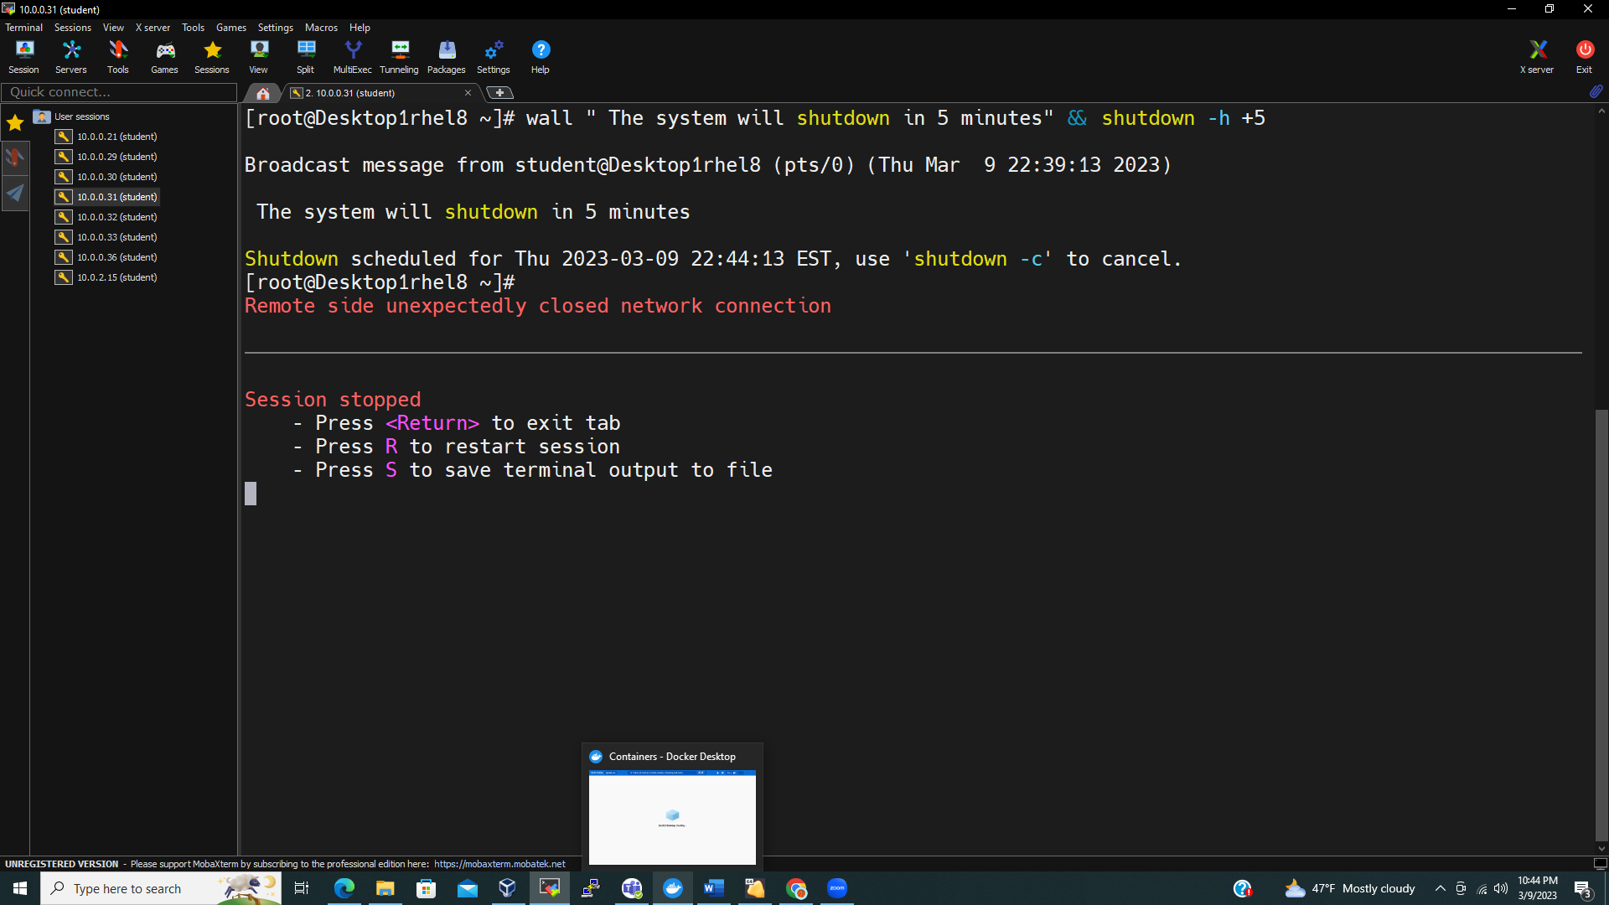

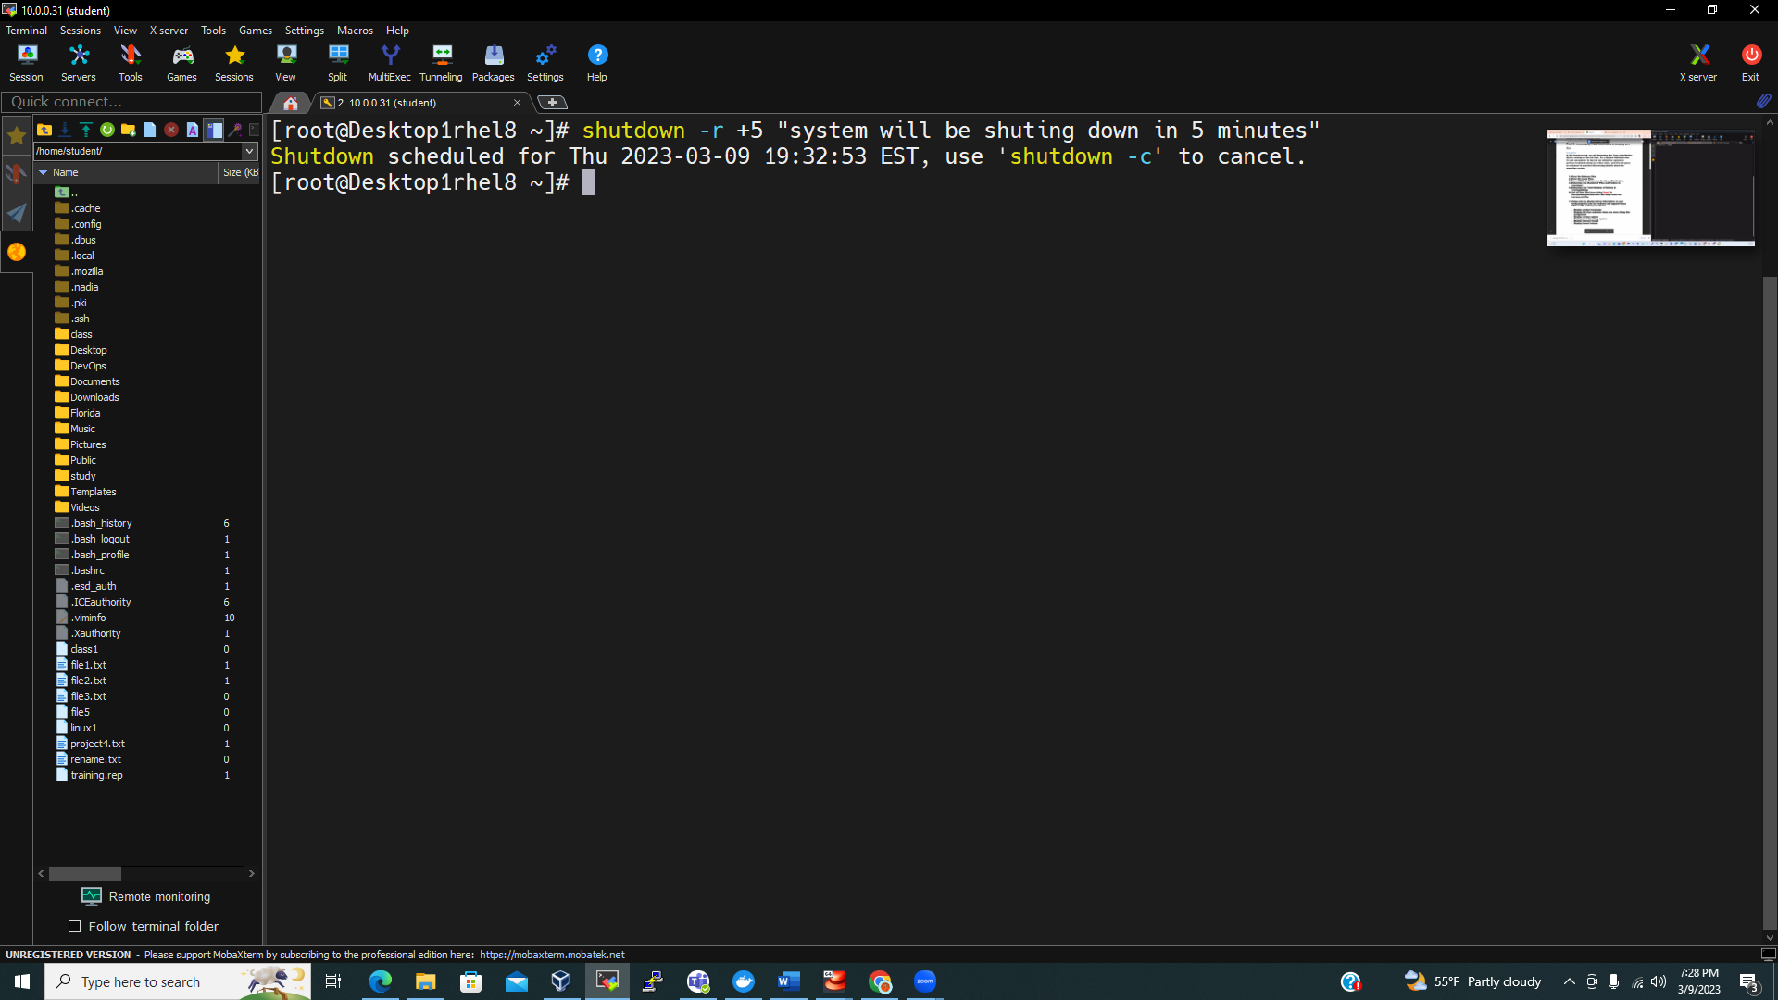

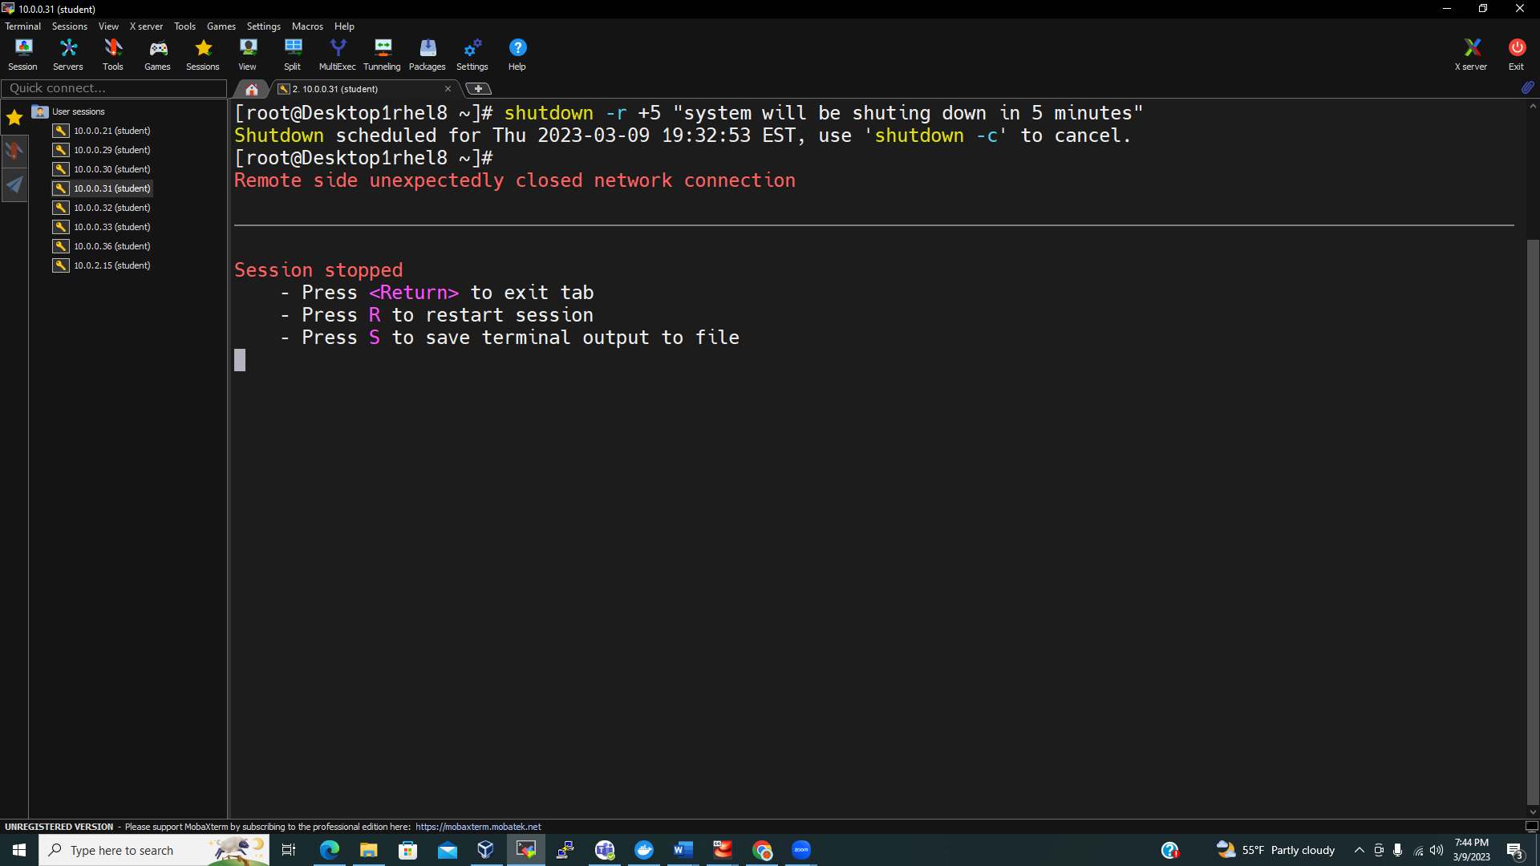

2-

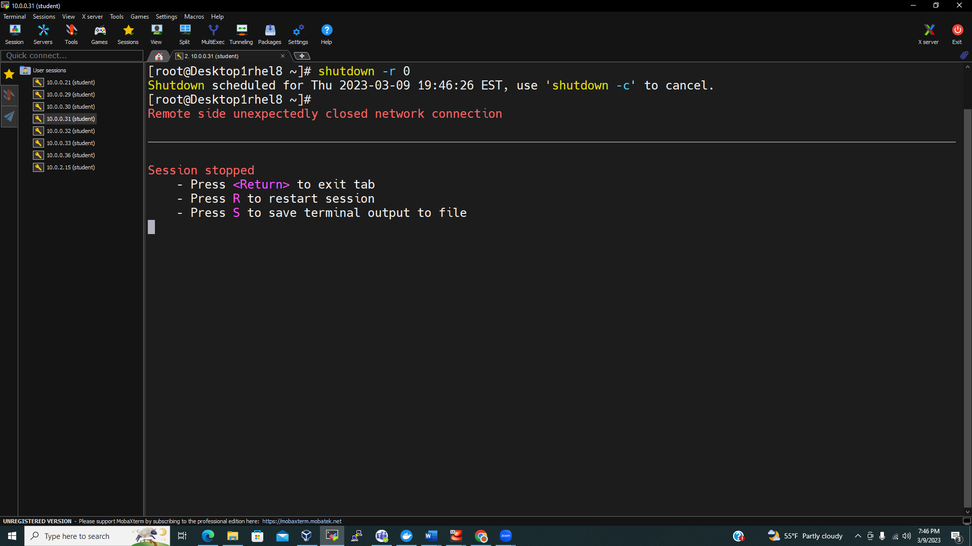

3-

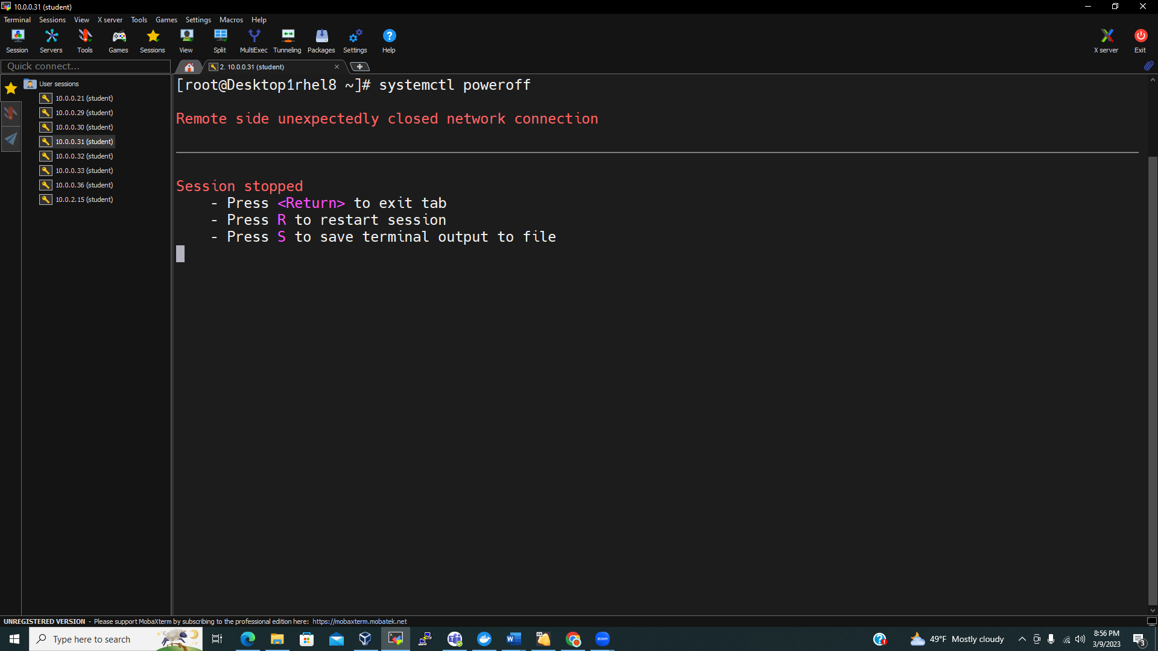

4-5

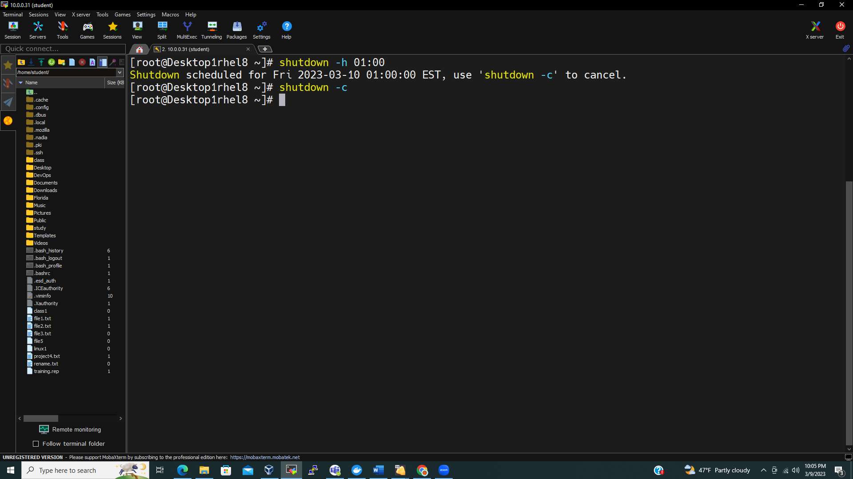

6-

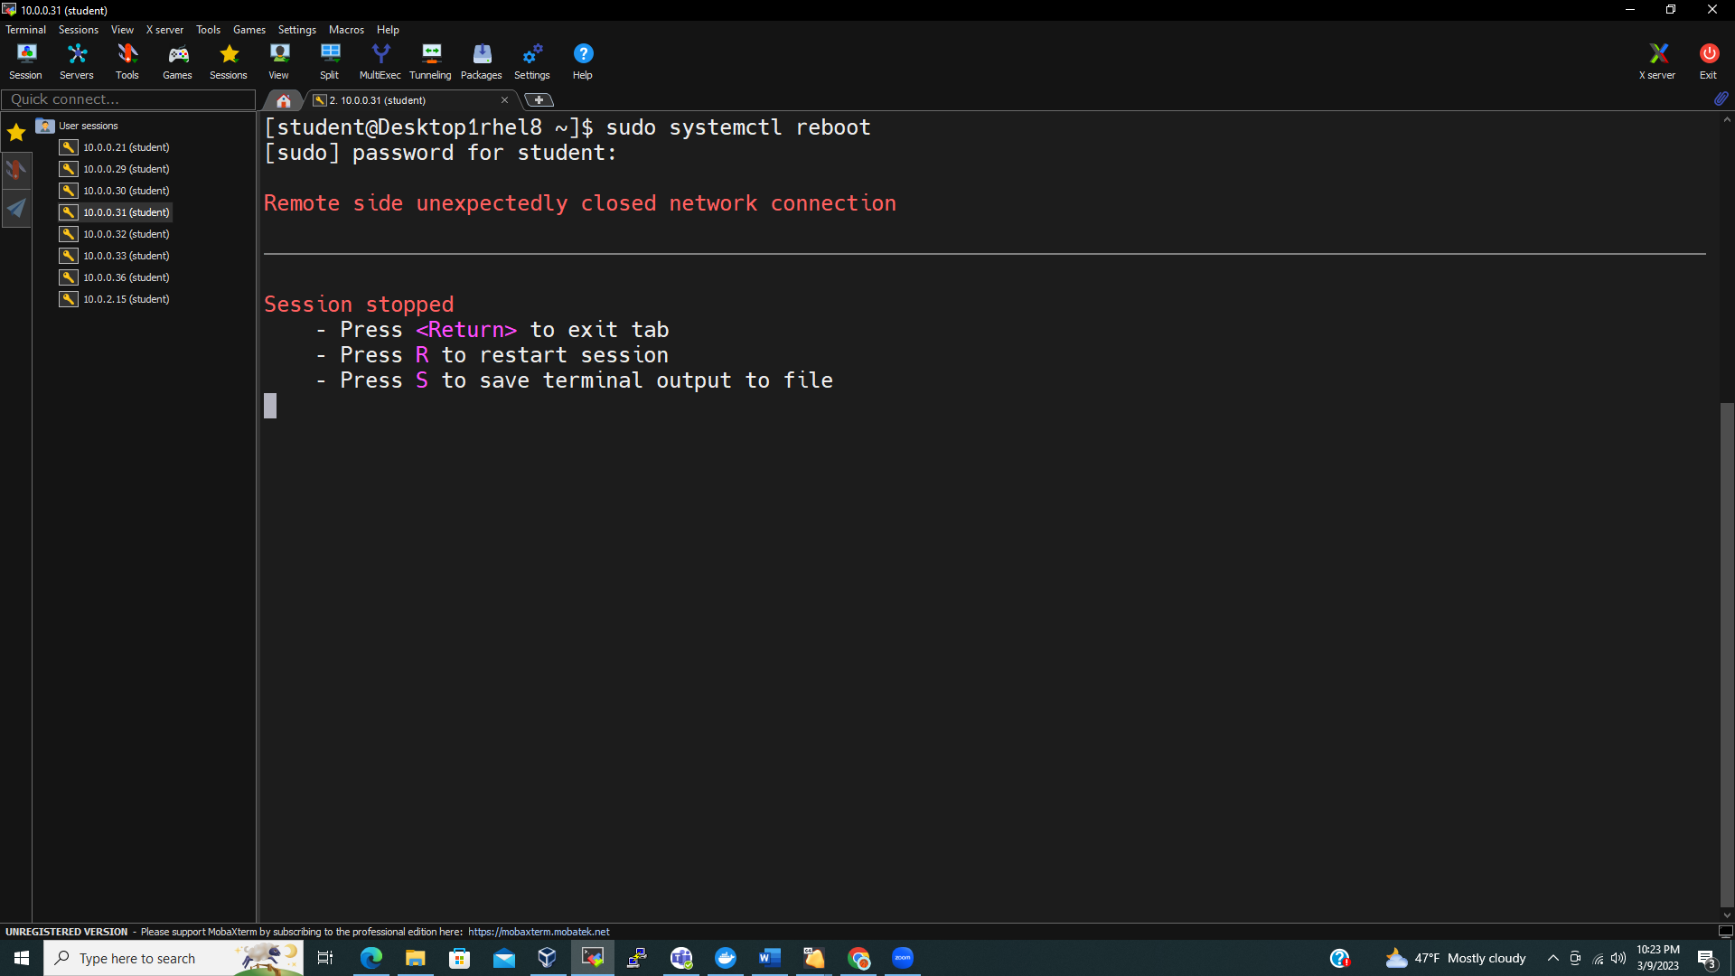

7-

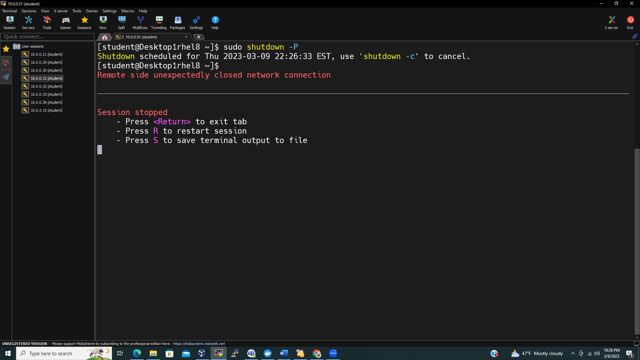

Part 4:

-

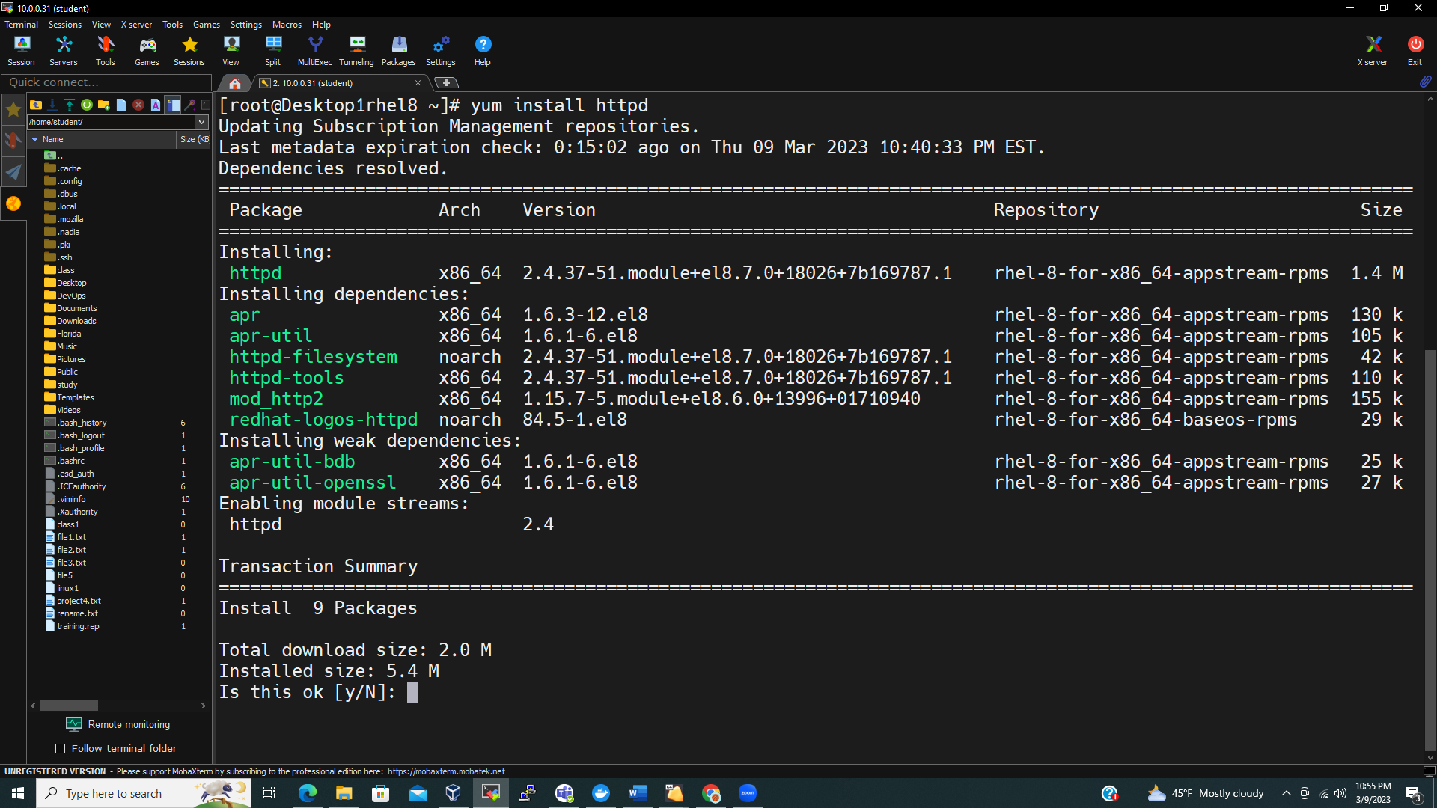

2-

3-

4-

5-

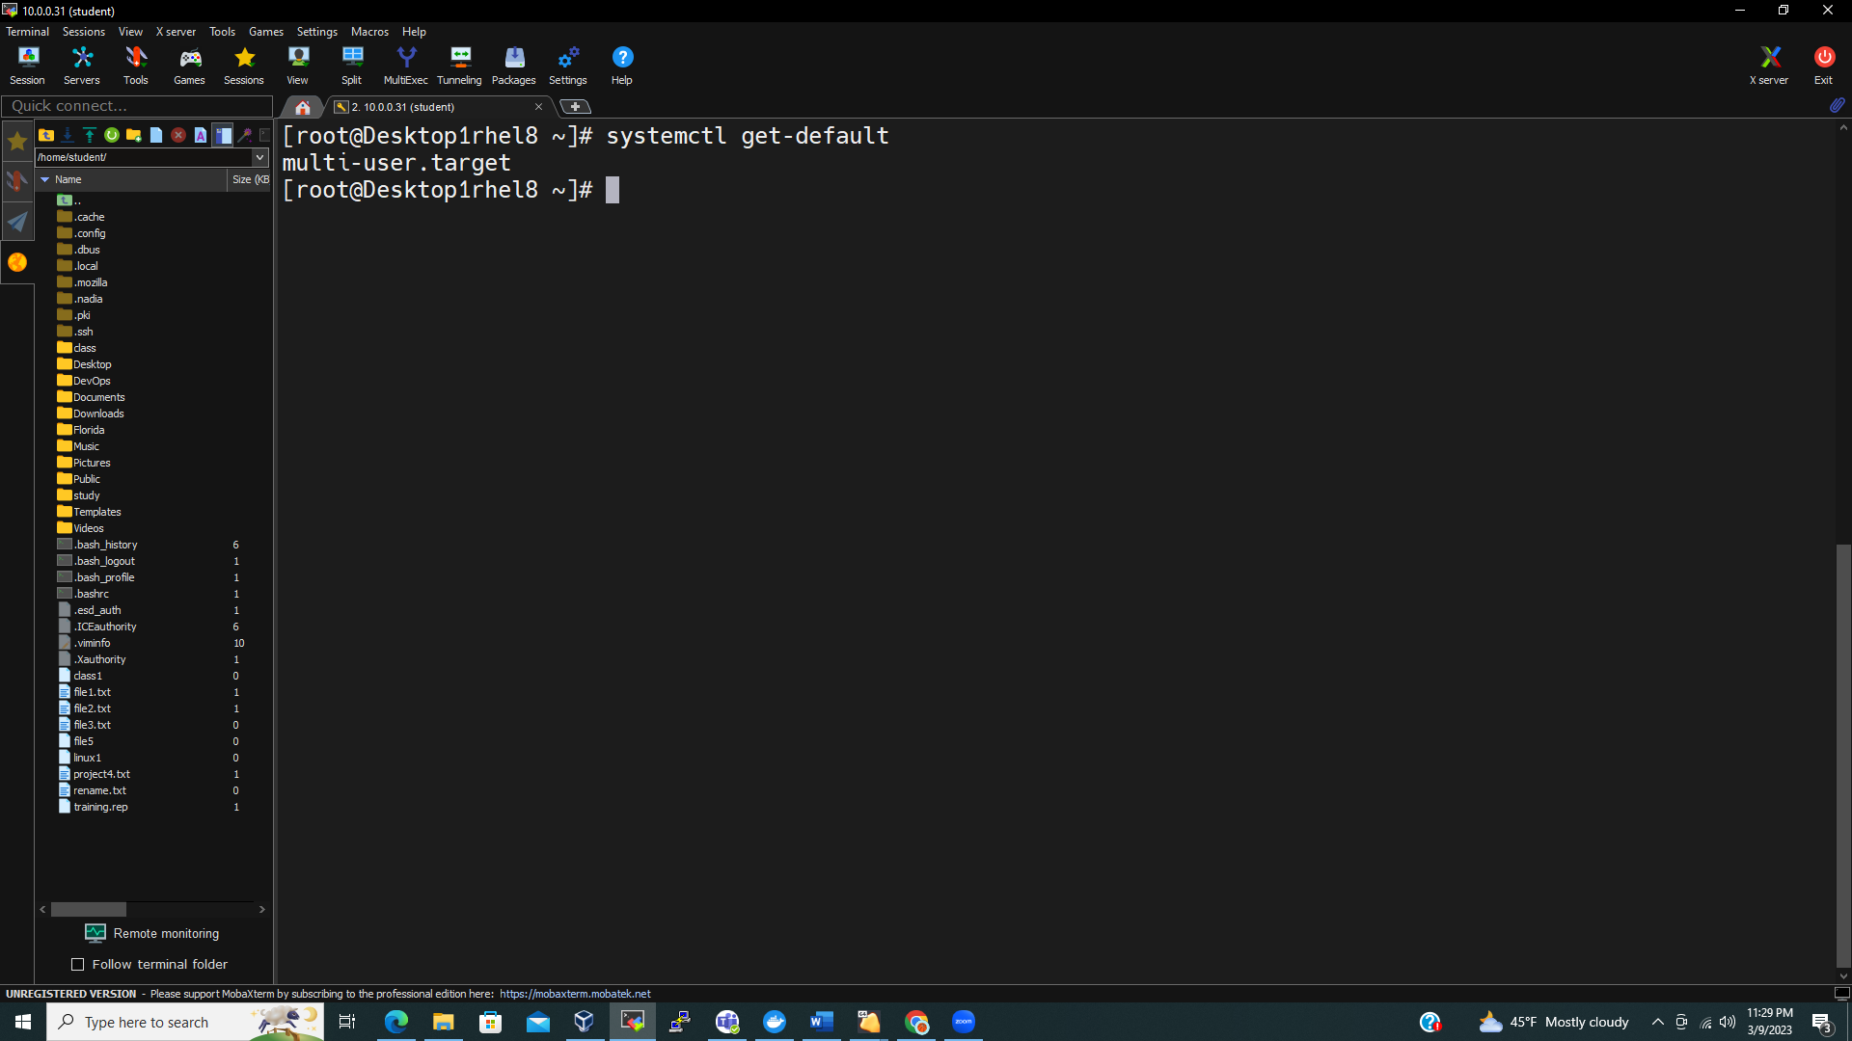

6-systemctl –service

7-

8-

9- systemctl is-active httpd

10- systemctl is-enable httpd

11-

12-

